MidGlos IBC Newsletter issue 282. Mar 9th 2026

Hello again,

The report from Simon Burke about our young stars from last week came in too late for last week’s newsletter. So here it is:
National U25s Two Rink
Gloucestershire v Durham

National U25’s Two Rink
Gloucestershire vs Durham

Gloucestershire travelled up to Derbyshire to face Durham in the quarterfinals. As they started out Glos got off to a great start forging ahead, the best of starts you could ask for, but it wasn’t long before Durham found the green to get themselves back into the game and chipping away at Glos’s lead. As we got to the middle of the game it was a real tit for tat kind of game, all low scoring ends with Glos just keeping ahead but Durham keeping the pressure on, you could tell from the sideline that it could go either way.
As they got to the business end of the game on rink four, our Glos rink of Jack, Emily, Dylan and Finley dropped a four which put them behind, on rink one which was Hattie, Erin, Louie and Josh, it was a bit of the opposite way round where Durham was holding around four shots but with no back woods, Josh took the risk to play the jack, taking it clean in to the ditch picking up four.
On the final end, rink 4 were trailing by three shots, but playing amazing, as Finley drew his last bowl in, Glos were holding four shots for game on this rink and looking hard for Durham to get into the head, let alone get shot, their only hope was to play with weight and to be somewhere in the area, hoping for the best. This is exactly what happened, the bowl left the skips hand and went flying up the rink, it was in the area and with a clatter of bowl going everywhere is could have been anyone’s, as the bowls came to a stop some how Durham were holding shot and that’s bowls for you, if your up and in the area anything can happen.
Lucky on Rink 1, it was very much the other way around with no matter what Durham did Glos had a answer to them, whether it was Durham was holding a few and Glos would come in to draw shot or get a strike smack on, to get the Jack off the rink to kill the end, which happened six times, Glos was relentless in their bid to stay on top and win the game by I think 10 shot on their rink and 6 shots over all.
Gloucestershire vs Durham was amazingly exciting and played well by both teams, but there could be only one winner, and this day belonged to Gloucestershire with a fantastic team effort and comments of encouragement flying from one rink to the other throughout the hole game. As I watched from the sideline, I could not be more proud of this young team “well done Glos” and on to the semi-final.
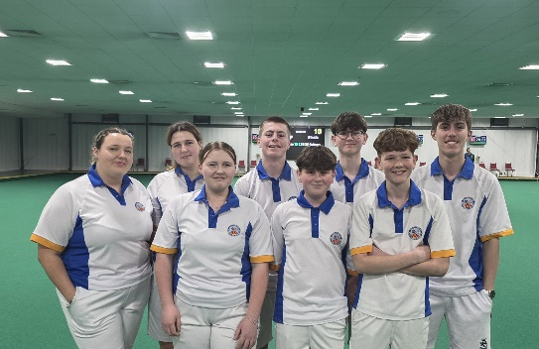

Great report of a great game! Well done Gloucestershire - and all MidGlos players! Wonderful win!

Having come top of the area and reached the last 16, Wessex A’s journey came to an end today. They began well but, as the game developed, Barwell started to catch up and make a very close game of it. However, in the last few ends, our away team were too far behind for us to win. I’ve never played at Barwell but apparently it’s a very fast green with tricky lines.

As a team you’ve had a very good season so you can all be proud of yourselves. Reaching the last 16 in the country is a very commendable achievement.

The friendly match on Friday afternoon played against the Devon men was won, I’m pleased to say, by MidGlos 103-75. The away team were very appreciative of our catering and volunteers.

This afternoon, MidGlos was playing against Gloucester Vice Presidents Bowling Association. A great win for us 122-81. Thanks must go to Jill and Chris along with various kitchen and bar volunteers. Very much appreciated.

This Saturday sees the Tony Allcock game, men v ladies. The ladies are up for taking the trophy from the men. This won’t be possible if we don’t have the numbers. We are still short especially of ladies. Come on everyone! This is a long-standing tradition!

On Monday, 16th March, at 12.30 it is the annual ladies’ meeting. All ladies are encouraged to attend. It is usually quite a short meeting but it is important since our ladies’ Captain, Gill Fry will give a report of this year’s performance and we will discuss next year’s entries. Gill is retiring from this role having served us well for a number of years.

The following afternoon, we welcome the Kent ladies to play in a friendly.

For the regular members who missed last week, there is no yoga this week on 11th. All being well, the session should go ahead the following week.

On Tuesday, 24th March, Mark Royal is visiting again with bowls and bowling gear from 12.00 until 7.00p.m. Again, this is open to anyone interested in purchasing bowls-related items. You do not have to be a member of MidGlos.

The Cherry Reds are back on Saturday, 25th April.
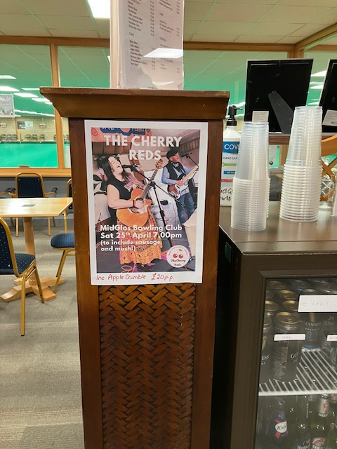

Please come along to support. They were very good last time. Tickets will be available soon.

Until next time, take care,

Linda.

Linda Watkin-Jones.
Director (PR & Marketing)

